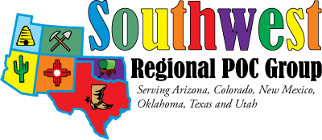

November 3 & 4 2016
Oklahoma City, Oklahoma

Dear Vendor Parnter,

The date and place are set! All we need is your support.

The support of vendors has made the SWRPOCG’s annual meeting a huge success and a meeting that Point of Care and Laboratory professionals look forward to attending each year. Your contribution to SWRPOCG’s 13th year anniversary meeting November 3 & 4, 2016 will continue this tradition.

SWRPOCG is a not for profit 501(c)(3) charitable organization that relies on your contributions to provide affordable educational and networking opportunities to individuals involved in the oversight of point of care testing.

Your contribution this year will allow your company to participate in the vendor exhibits. This includes:
- Separate vendor area set aside from the meeting space.
- Dedicated exhibit time for participants along with prize drawings for participants who visit vendors. Limited spots are available with power connections if those will be needed for your display items.
- Display table and draping.
- Dinner on Thursday night with the SWRPOCG members for one vendor per company, additional dinners available for a fee

Your contributions are greatly appreciated and will be recognized on our webpage at www.pointofcare.net/Southwest/index.htm and in our meeting agenda.

Sponsorship levels:
Sustainers | $3,000 or more
Benefactors | $2,000 to $2,999
Sponsors | $1,000 to $1,999
Donors | $500 to $999
Contributors | Up to $499

In addition, other sponsorship opportunities are available.

If you decide to sponsor, please fill out the attached form and send in.

Please contact me should you have any questions. We’re looking forward to seeing you in November!

Location of the meeting:
St. Anthony’s Hospital, Oklahoma City, OK

Hotel Accommodations: Information to follow

Sincerely,
Leslie Ogle, President
SWRPOCG
Phone:405-272-6179
Email: leslie_ogle@ssmhc.com

